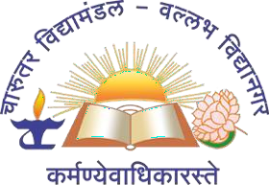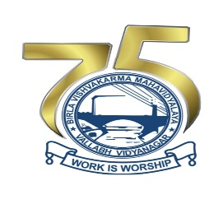

MECHANICAL DESIGN OF SPACE

TELESCOPE
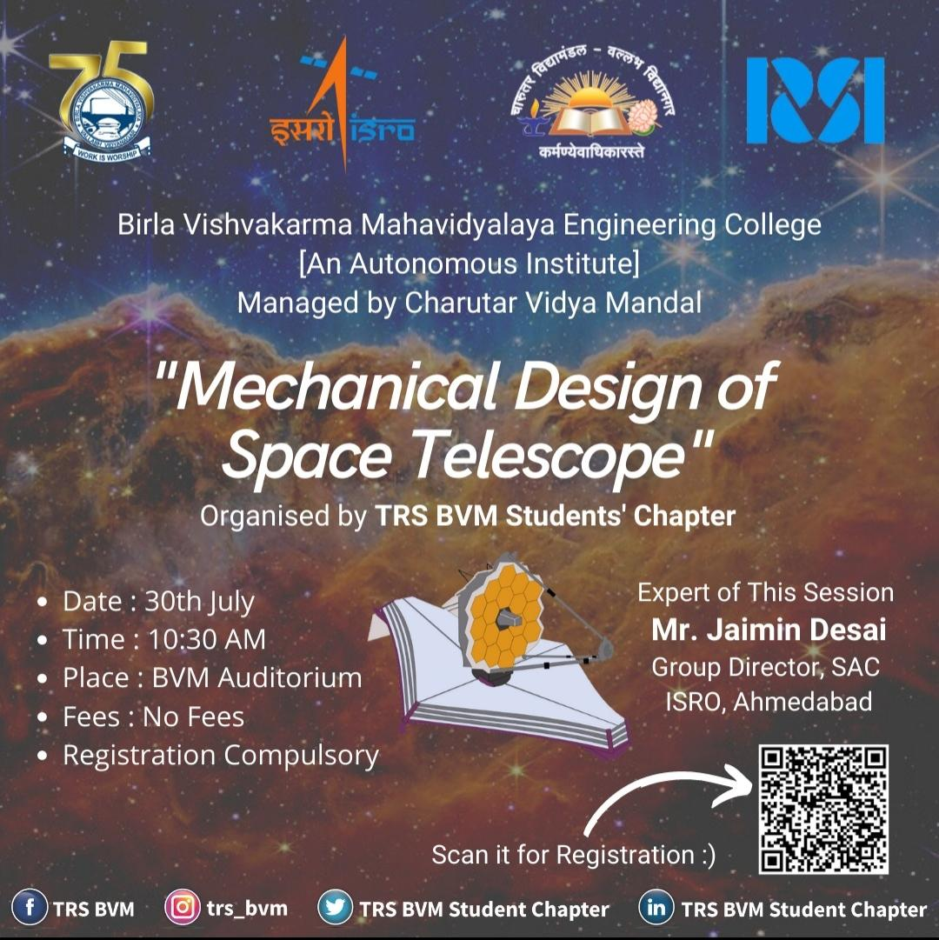

BVM ENGINEERING COLLEGE
Title of the event/workshop | Mechanical design of space telescope
Name and Designation of the Experts: | Name | Designation
Name and Designation of the Experts: | Mr. Jaimin Desai | Group Director  (EnTSG/ESSG), SAC ISRO
Name of the Institute | Birla Vishvakarma Mahavidyalaya Engineering College
Name of the Principal of the Institute: | Dr. Indrajit Patel
Year/Semester of the Students: | Under Graduate Students[2nd year/3rd year]
Professional body  under which event organized: | TRS BVM Student Chapter
Date and Time of the Event/Workshop: | Date: 30th July 2022, Saturday Time: 10:30PM to 12:00PM
Venue Name | AUDITORIUM
No. of Days for Event/Workshop | 01
TRS BVM  Counsellor’s Details: | Name: Dr. Vinay Patel  Prof. Alpesh Damor  Prof. Ashish Thakkar  Prof.Vijaypratap .R.Singh
Total No. of Students: | 200+

SUMMERY TABLE

\ 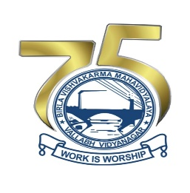

Objective of the Event:

- The purpose of the event was to give detailed introduction about mechanical design of space telescope.

Expected Outcome

Participants were able to understand about the significance and basic design of various types of telescope used for space exploration.

About the Speaker

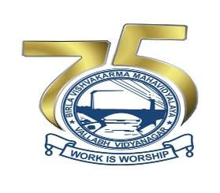

About The Event

- On 30th July, 2022 an expert talk was organized by TRSBVM Students Chapter. Expert talk was on topic of advanced solid modelling using solidworks from 10:30 am to 12:00 pm.

- Our expert, Mr. Jaimin Desai, the Group Director (EnTSG/ESSG), SAC ISRO.
- The Inauguration ceremony was conducted by HOD Mechanical Department Dr. P.M George, Dr.Vinay Patel, and Prof. Ashish Thakkar.

- The session was initiated by Mr. Jaimin Desai on detailed introduction on mechanical design of telescope. In which he gave breif information about suitable material used for specified function in space telescope such as carbon fiber. Which type of mirror should be used and dimensions of the design for optimum output of the designed telescope. Also he gave the idea about polishing head design with specified diameter of polishing wheel and various type of electrolyte used and mapping of data collected by telescope.
- Further, he presented the projects on which he worked and ongoing project under his guidance. And also, gave the information about many international and national organisation that work in field of space telescope such as AMOS Belgium.
- At last the vote of thanks was given by Prof. ______ to our experts.

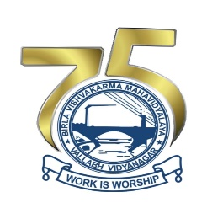

Glimpses of the Event
